POWER PLATFORM COMMUNITY CONFERENCE 2026
Conference Summary & Recommendations
Las Vegas, NV | October 27–29, 2026

Prepared by: Gino Cuccia
Date: November 3, 2026
Audience: Leadership
Sessions covered: 7

INTERNAL USE ONLY. Contains slide images from Microsoft presentations, some marked “Microsoft Confidential.” Do not distribute outside Leidos.

Contents
Executive Summary
Key Themes Across Sessions
Recommended Next Steps
Session Summaries
Session 1: Keynote
Session 2: Beyond the Basics: the GitHub Copilot Harness
Session 3: DevOps in Power Platform (Managed Operations)
Session 4: Full Stack with Code Apps
Session 5: The Copilot Compass
Session 6: Build Fast, Govern Better
Session 7: Managed Run Apps vs Power Pages
Open Questions Answered
Key Dates & Resources

Executive Summary
Microsoft used PPCC 2026 to signal a major shift: Power Platform is moving from “low-code tools that humans drive” to “a governed platform where AI agents build, run, and operate business solutions.” Power Platform now has roughly 80 million monthly active users (up from 56 million last year), and nearly every announcement centered on Copilot, agents, and a new hosting layer called Copilot Managed Runtime (CMR).
Three messages stood out for leadership:
- AI can now build the app; governance is the hard part. Apps can be generated in minutes from Copilot, GitHub Copilot, Claude, VS Code, and others. Microsoft’s answer is a managed host that applies identity, connector policies, monitoring, and approvals automatically—so IT stays in control regardless of where the code was written.
- Delivery and operations are being simplified. A new Git-based ALM model lets most apps move from dev to test to production inside a single environment, with built-in approvals. Monitoring alerts move from daily to hourly and can be routed to Teams or Azure DevOps.
- Costs are shifting to consumption. Cowork, Autopilot, Code, and CMR apps are metered in Copilot Credits. Seeded AI Builder credits ended November 1, 2026. Spend policies and caps need to be in place before these capabilities are turned on.

Top recommendations
1. Set Copilot Credit allocation and spend caps per environment now.
2. Review Advanced Connector Policies, Content Security Policy, and hourly Monitor alerts before makers publish AI-built apps.
3. Pilot one Copilot Managed Runtime project using single-environment ALM and GitHub integration.
4. Inventory existing agent flows and autonomous agents; plan migration to the new Workflows.
5. Train staff on which Copilot mode fits which job (Chat, Cowork, Autopilot, Agents) rather than on product tours.

Key Themes Across Sessions

1. From assistant to “autopilot”
Copilot is evolving from a chat helper into a coworker. Agents can now have their own identity, mailbox, OneDrive, and memory; they can be emailed or chatted with in Teams, and run on schedules. Scout has been rebuilt for the cloud and renamed Autopilot (renamed September 25, 2026).

2. Workflows replace agent flows
Cloud flows → agent flows → Workflows. Workflows run in Copilot Studio and combine deterministic steps with AI nodes, inline agents, human approvals, and custom code. The benefit for the business: predictable cost, traceability, and guardrails built into the process rather than left to the AI.

3. Copilot Managed Runtime: build anywhere, IT governs
CMR is a new managed host for AI-built apps and agents. Makers can build in their tool of choice; the platform enforces Entra sign-in, sharing limits, connector policies, CSP, Purview logging, and approvals. It is in public preview, with general availability and server-side logic on the roadmap.

4. Simpler, Git-first ALM
A project equals a Git repo. Dev, test, and prod become stages, not separate environments. Microsoft expects ~80% of apps to never leave the environment they were built in. GitHub is now supported alongside Azure DevOps, and service principals enable automated deployments.

5. Operate with visibility
Monitor now offers hourly alerts, routing to Teams/Azure DevOps through Power Automate, export for long-term retention and custom dashboards, and Power Pages site health. Governance views in the admin centers provide agent inventory, connector controls, and cost management.

6. Consumption-based cost model
Your seat license covers Copilot Chat. Cowork, Code, Autopilot, and CMR end-user access consume Copilot Credits. Credits are allocated per environment in the Power Platform admin center, with per-agent monthly limits and alerts.

Recommended Next Steps
Action | Why | Priority | Timing
Allocate Copilot Credits and set spend caps per environment | Seeded AI Builder credits ended Nov 1; metered features are spreading | High | Now
Review Advanced Connector Policies and CSP settings | Controls what AI-built apps can call and connect to | High | 30 days
Enable hourly Monitor alerts routed to Teams / Azure DevOps | Detect issues in ~1 hour instead of 24+ | High | When preview lands (Nov)
Pilot one CMR project with single-environment ALM + GitHub | Validate new model before broad adoption | Medium | Q1 2027
Inventory agent flows / autonomous agents for Workflow migration | Workflows give predictable cost and better guardrails | Medium | Q1 2027
Publish maker standards: AGENTS.md, approved skills, data-boundary guidance | “Instructions are a wish, not a rule”—standardize context | Medium | Q1 2027
Train staff on the Copilot Compass (Chat / Cowork / Autopilot / Agents) | Avoid one-mode misuse and wasted credits | Medium | Ongoing
Attend CMR and code apps office hours | Direct access to Microsoft product teams | Low | Nov–Dec

Choosing the right platform
Several sessions compared the new app options. A simplified decision guide:
Question | Copilot Managed Runtime | Power Apps code apps | Power Pages SPA
Best for | Internal apps built with AI tools; public or non-classified data | Internal pro-code apps needing Dataverse ALM | External-facing users and sites
ALM model | Git repo, stages (dev/test/prod) | Dataverse solutions | Dataverse solutions
Data access | Any connector, custom APIs | Connectors via Power Apps SDK | Dataverse Web API; Power Automate
Server-side logic | Coming (preview) | Not planned | Yes
Licensing | Copilot Credits or Power Apps premium | Power Apps premium | Power Pages licensing
Status | Public preview | Generally available | Generally available

Rule of thumb: Let the data boundary decide. Data that must be contained and audited belongs on Power Platform + Dataverse; external users point to Power Pages; anything Power Platform can’t host goes to Azure.

Session Summaries

Session 1: Keynote
Speakers: Charles Lamanna, Corporate Vice President, Microsoft
Why it matters
Sets the direction for the whole platform: Copilot becomes an active participant in work, and governance and cost management are built into the admin experience.

- Copilot → Autopilot: Copilot can be embedded in Teams as its own user and act on work items.
- Apps: Canvas apps get pop-out formulas, Dataverse optimization, and responsive layouts by default; model-driven apps get easier calendar views; apps can be built and shared directly from Copilot.
- Copilot Studio: New harness and UI with 48% less token input and 20% better outcomes.
- Agents: Built fully in natural language with automatic model selection, scheduled triggers, memory of previous runs, and their own mailbox, identity, and OneDrive.
- Developer tooling: Workflows and diagnostics available in VS Code.
- Governance: Agent inventory/map, connector controls, and Copilot cost management in the admin centers; a Power Platform advisory plugin in Cowork answers governance questions in natural language.

Session 2: Beyond the Basics: the GitHub Copilot Harness
Speakers: Giorgio Ughini, Alicja Gilderdale, Roel Schenk
Why it matters
Copilot Studio agents now run on a new engine. Existing agents should be re-architected, not simply ported, and Workflows replace agent flows with more predictable cost and control.

- New engine: The GitHub Copilot harness continuously reasons, acts, and observes rather than following a fixed plan.
- Building blocks: Instructions, Skills (reusable procedures loaded on demand), Knowledge, Tools/MCP, a code sandbox, Hooks (business-rule checkpoints), and per-user Memory.
- Connected agents are task-only; memory is not passed between agents.
- Workflows run in Copilot Studio with AI nodes, inline agents, human approvals, and custom code. Deterministic paths make cost predictable.
- Human-in-the-loop can be designed in (approvals, forms) or triggered by the agent when it is unsure.
- Resources: Copilot Studio Gallery (microsoft.github.io/copilot-studio-gallery) and an open-source demo solution on GitHub.
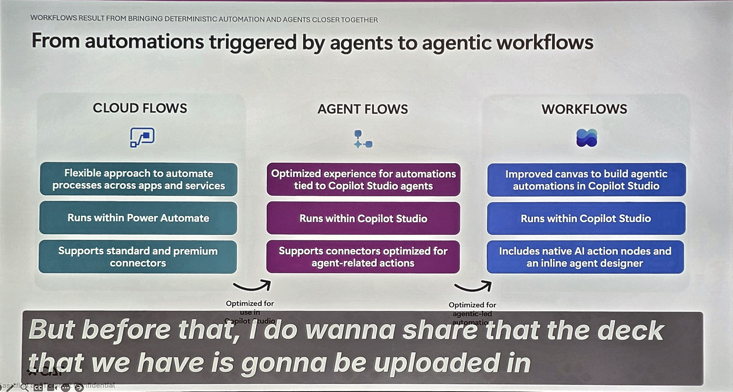
Evolution from cloud flows to agent flows to Workflows
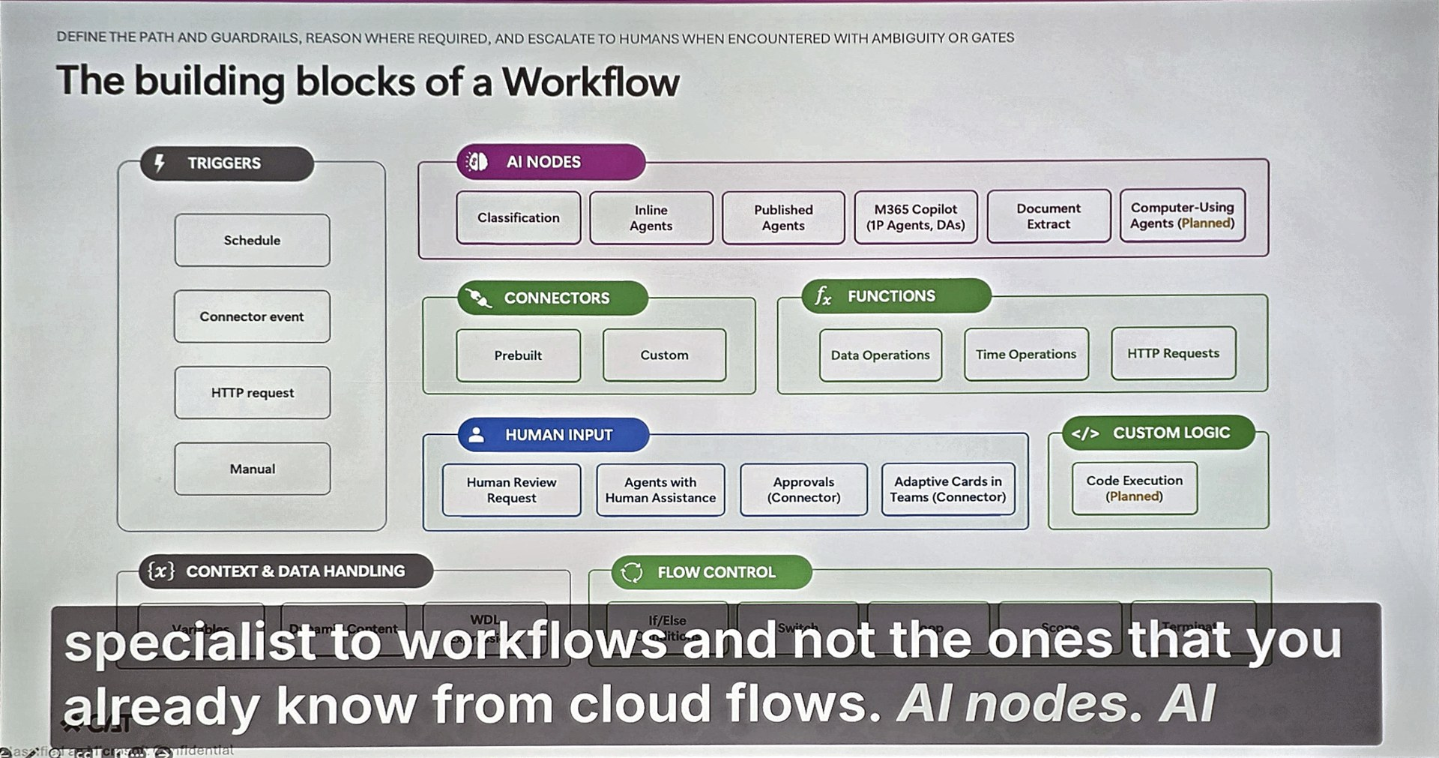
Building blocks of a Workflow
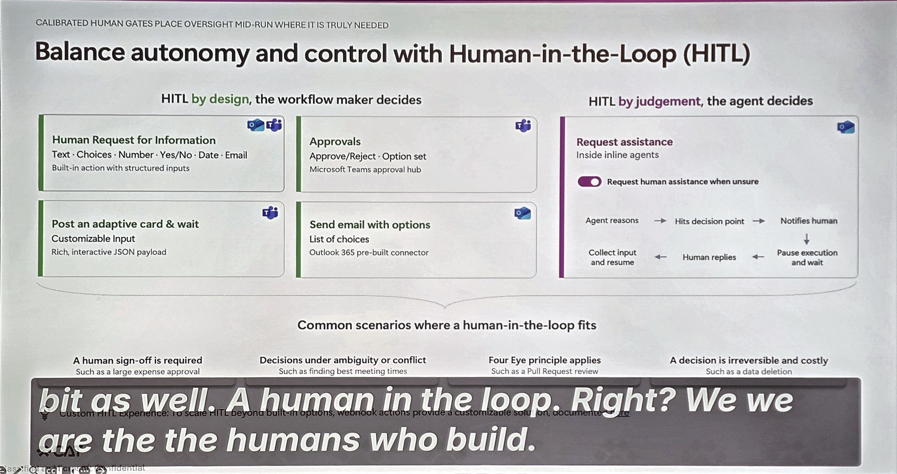
Human-in-the-loop options

Session 3: DevOps in Power Platform (Managed Operations)
Speakers: Casey Burke, Arjun Mayur, Greg Lindhorst (Microsoft); Christopher Robbins (Lummus Technology)
Why it matters
The most actionable session for delivery teams. ALM shifts from moving solutions between environments to moving Git commits through stages, with built-in approvals and much faster operational alerting.

- Generally available now: Power Platform Pipelines, default pipelines per environment group, native Git integration (GitHub now in preview alongside Azure DevOps), and Monitor.
- Project = Repo: CMR apps live in a Git repo and deploy through dev, test, and prod stages.
- Single-environment ALM is the default: ~80% of apps stay in the maker’s environment, ~15% in a shared environment, ~5% need full multi-environment ALM. Fewer moving parts, same governance.
- Approvals: Project Owner assigns approvers; Contributors (including agents) can deploy but not approve. Approve via CLI, email, or portal. Service principals supported.
- Monitor: Hourly alerts (mid-Nov preview), routing to Teams/Azure DevOps via the “When an alert fires” trigger, data export beyond 30 days via REST API, and Power Pages metrics (end-Nov preview).
- Customer example: Lummus Technology uses agents to auto-draft release notes, training videos, and SharePoint pages on each deployment, with human review before publishing.
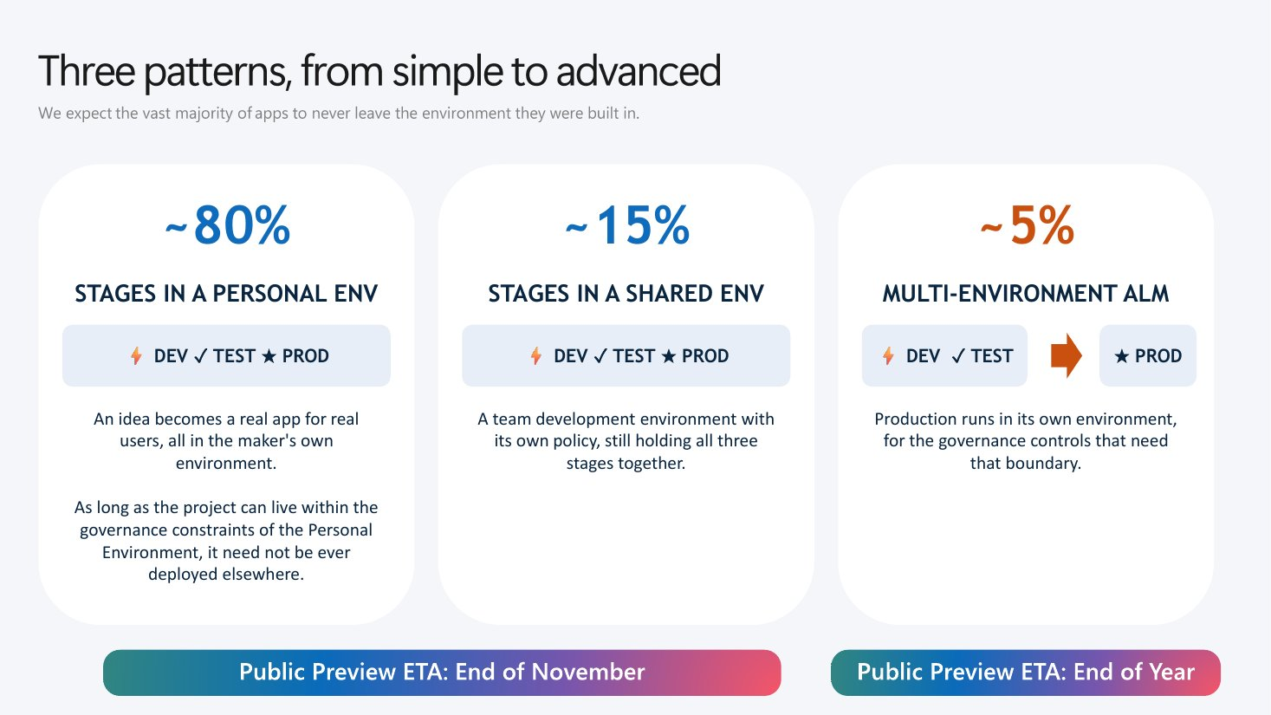
Three ALM patterns, from simple to advanced
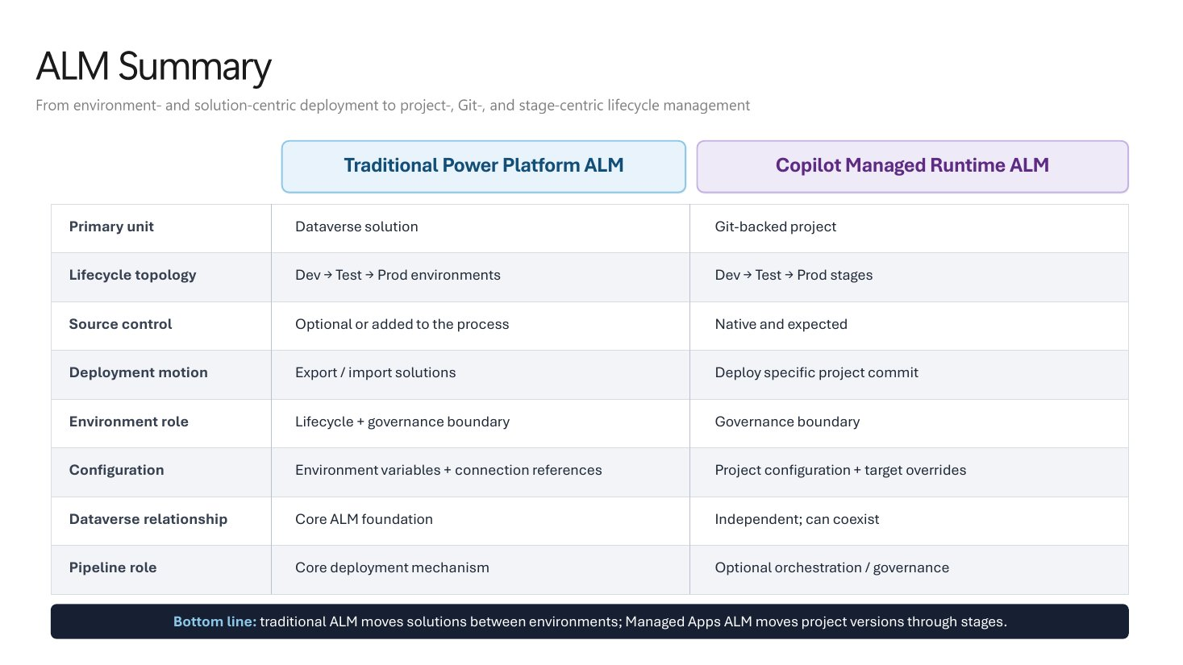
Traditional vs Copilot Managed Runtime ALM
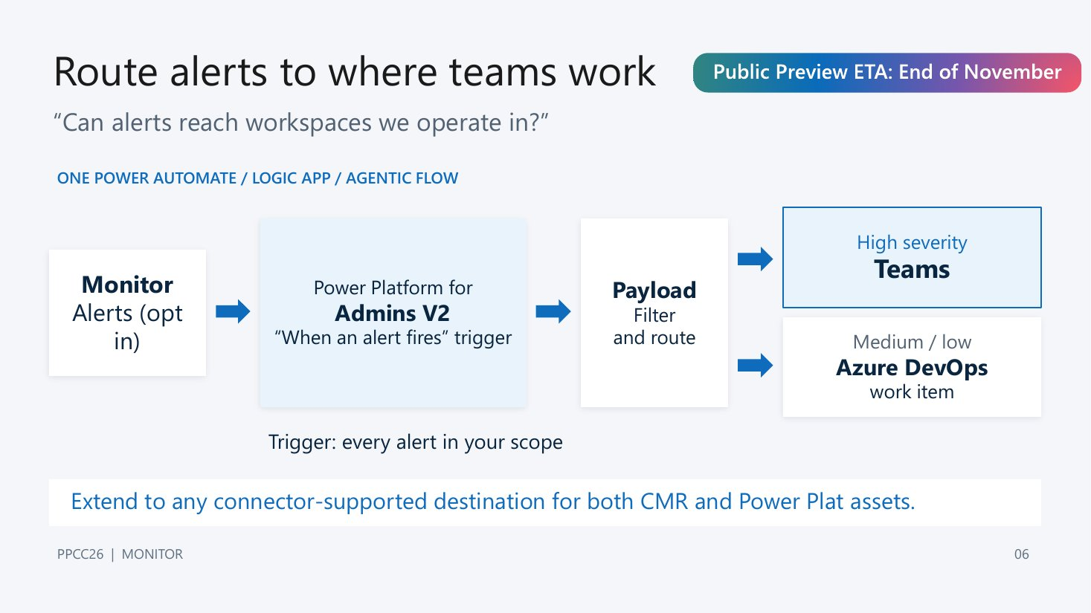
Routing Monitor alerts to where teams work

Session 4: Full Stack with Code Apps
Speakers: Tomas Prokop (TALXIS)
Why it matters
Giving makers AI coding tools is powerful but risky: “more code, more problems.” The data boundary should decide which platform an app is built on.

- Three loops: inner (build/test), outer (integrate/release), and security (monitor/harden).
- Five layers of every AI coding tool: model, context, harness, runtime, and client.
- “Instructions are a wish, not a rule”: standardize AGENTS.md, skills, and MCP servers for makers.
- Build in layers: data model → logic → security → UI.
- Code apps: React/TypeScript apps running under Power Platform governance via the Power Apps SDK; code lives in GitHub.
- Maturity: Power Platform + Dataverse remains the most mature for security, secrets, and background jobs; CMR is simpler but early.
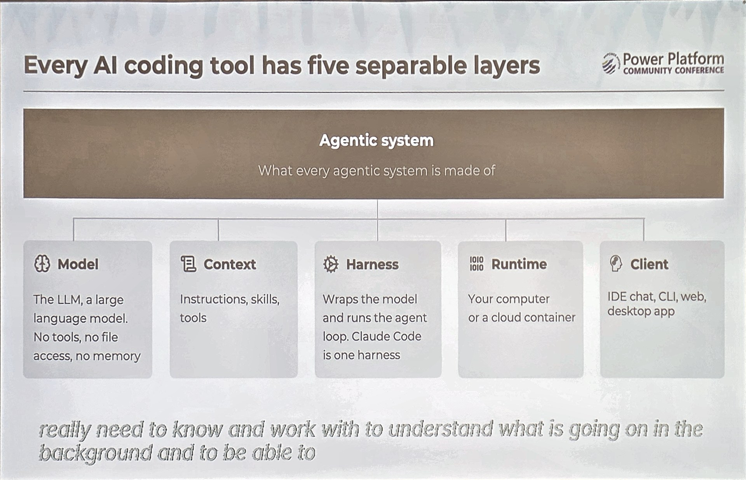
Every AI coding tool has five separable layers
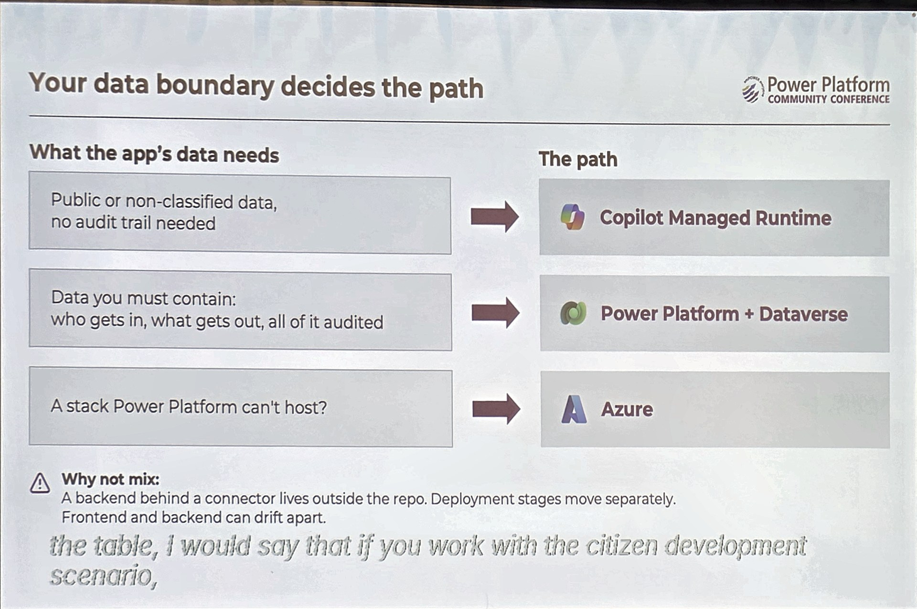
Your data boundary decides the path

Session 5: The Copilot Compass
Speakers: April Dunnam, Bryan Wofford (Microsoft)
Why it matters
Copilot is now one app with several modes and two cost meters. Choosing the right mode for each job is the difference between real productivity and wasted credits.

- North – Sharpen (Chat): thinking partner; included in the seat license.
- South – Delegate (Cowork): a contractor that hands back a finished deliverable; Copilot Credits.
- East – Monitor (Autopilot): ongoing work with no finish line; formerly Scout, now cloud-based with its own identity; Copilot Credits; broad rollout by year end.
- West – Scale (Code, Agent Builder, Copilot Studio): package repeatable work for the whole team.
- Office apps now act, not suggest: Excel builds analyses, PowerPoint builds decks from meetings and files, Word revises with Track Changes. Models from OpenAI and Anthropic are available.
- Rule of three: done it by hand three times? Make it an agent.
- Pitfalls: one chat for everything, credits without caps, humans as copy-paste middleware, Autopilot without guardrails, rolling out tools instead of workflows.
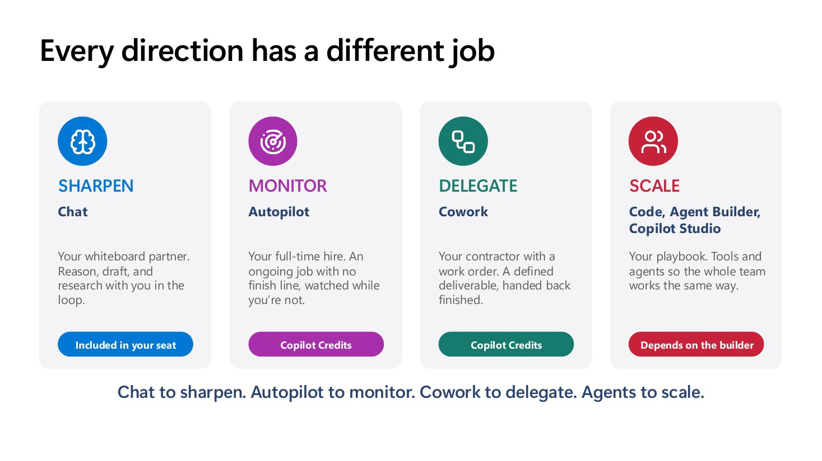
Each Copilot mode has a different job
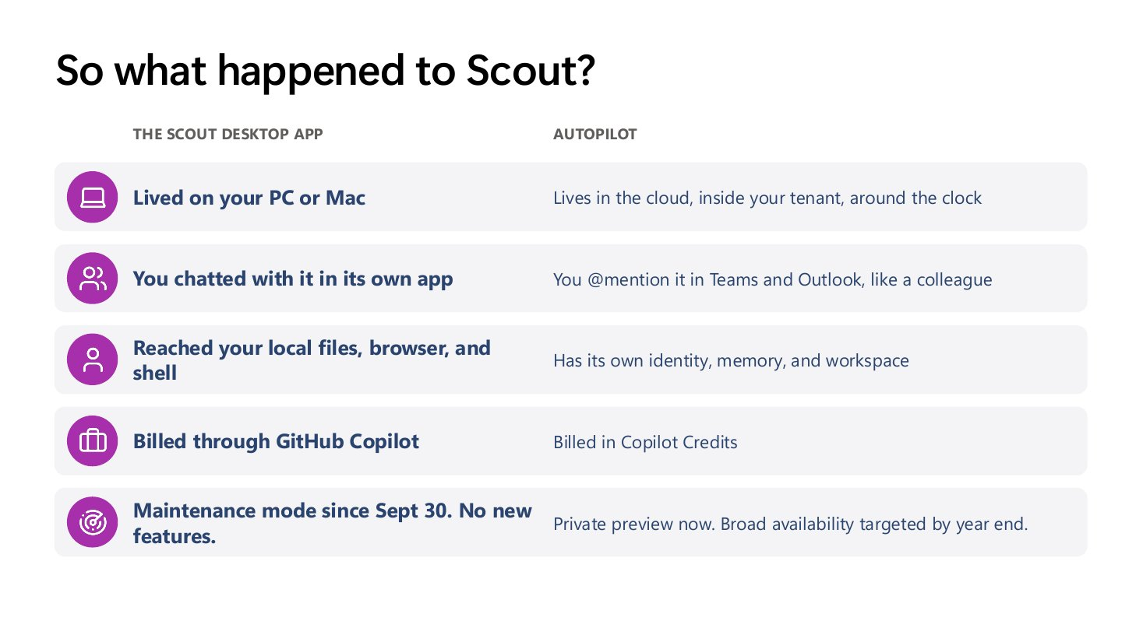
What changed from Scout to Autopilot
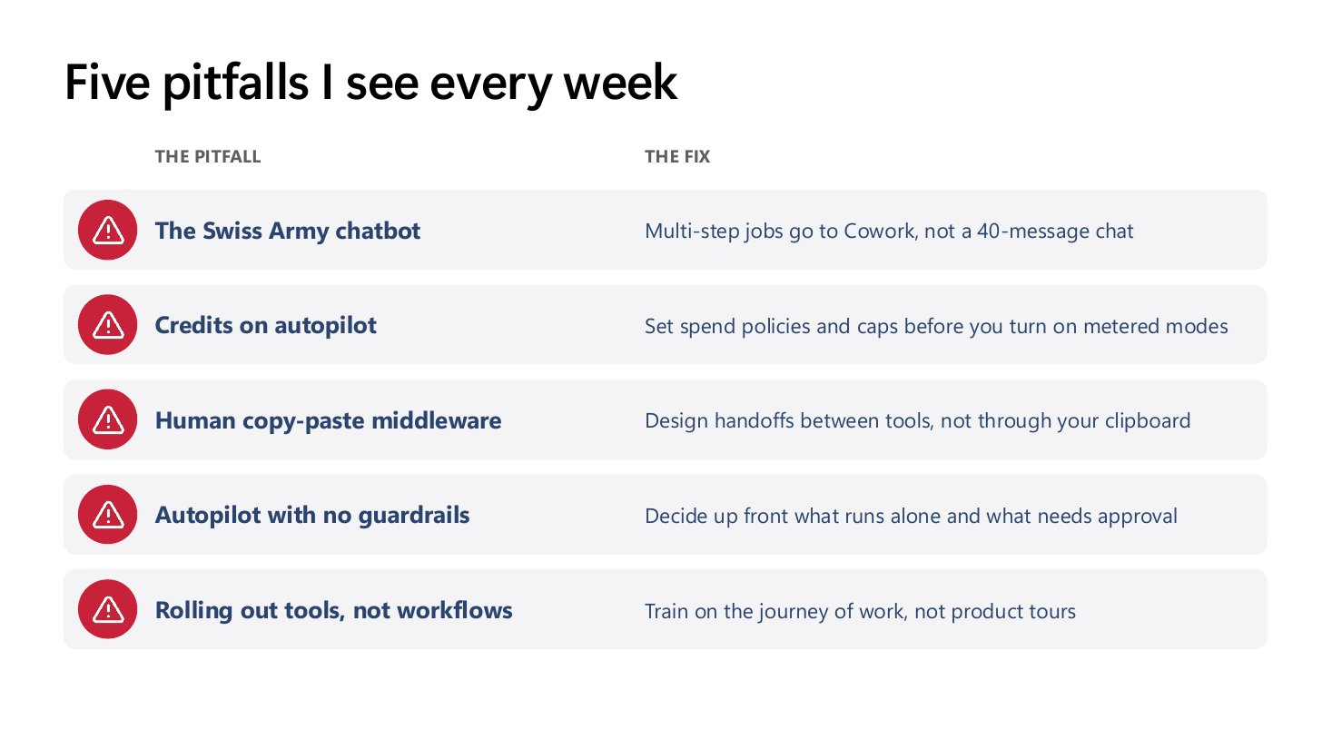
Common pitfalls and fixes

Session 6: Build Fast, Govern Better
Speakers: Jordan Chodak, Ryan Jansen, Austin Laugesen, Alan Castellanos Moreno (Microsoft)
Why it matters
“Writing code is the easy part.” The managed host closes the gap between an AI-generated app and an enterprise-ready one, keeping IT in control wherever the app was built.

- CLI and SDK: the SDK is the library app code calls to reach connectors and Dataverse; the CLI lets developers or coding agents create and publish apps with governance metadata built in.
- Code apps: deeper Dataverse integration, embedded Copilot Studio agents, and service-principal deployments.
- Secure by default: Entra sign-in, sharing limits, Advanced Connector Policies (environment or group level), Content Security Policy, Purview logging; Conditional Access coming.
- Coming in early 2027: Copilot side pane and Cowork hand-off in code apps, deep links.
- CMR roadmap: GA, native Cowork integration, integrated data with role-based access, and server-side logic (CMR only—not coming to code apps).
- Licensing: CMR end users need Copilot Credits or Power Apps premium licenses.
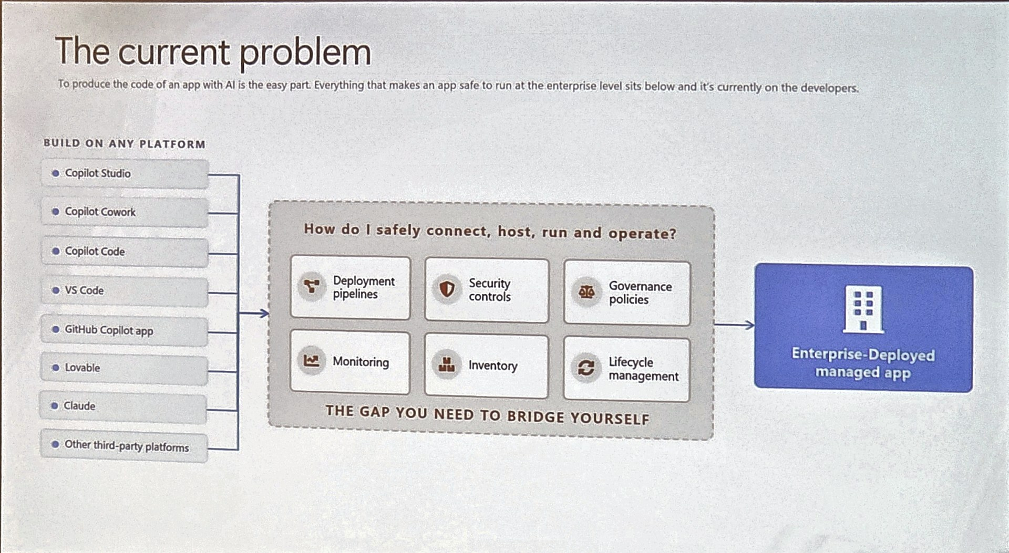
The gap between AI-generated code and an enterprise app
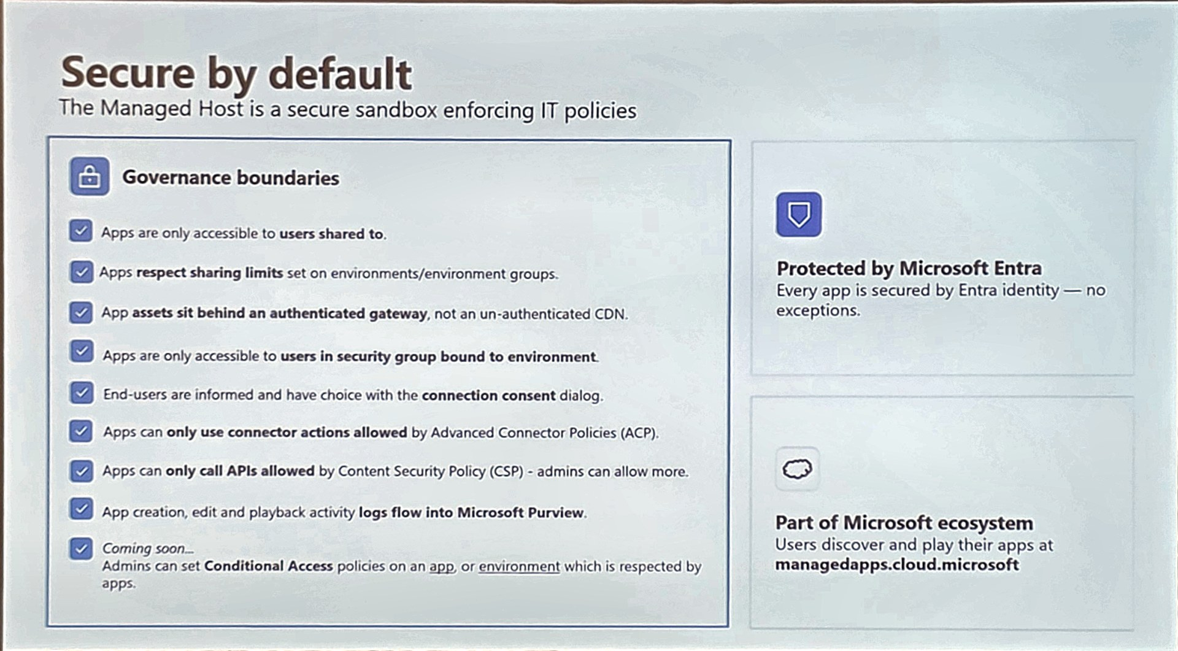
Managed Host governance boundaries
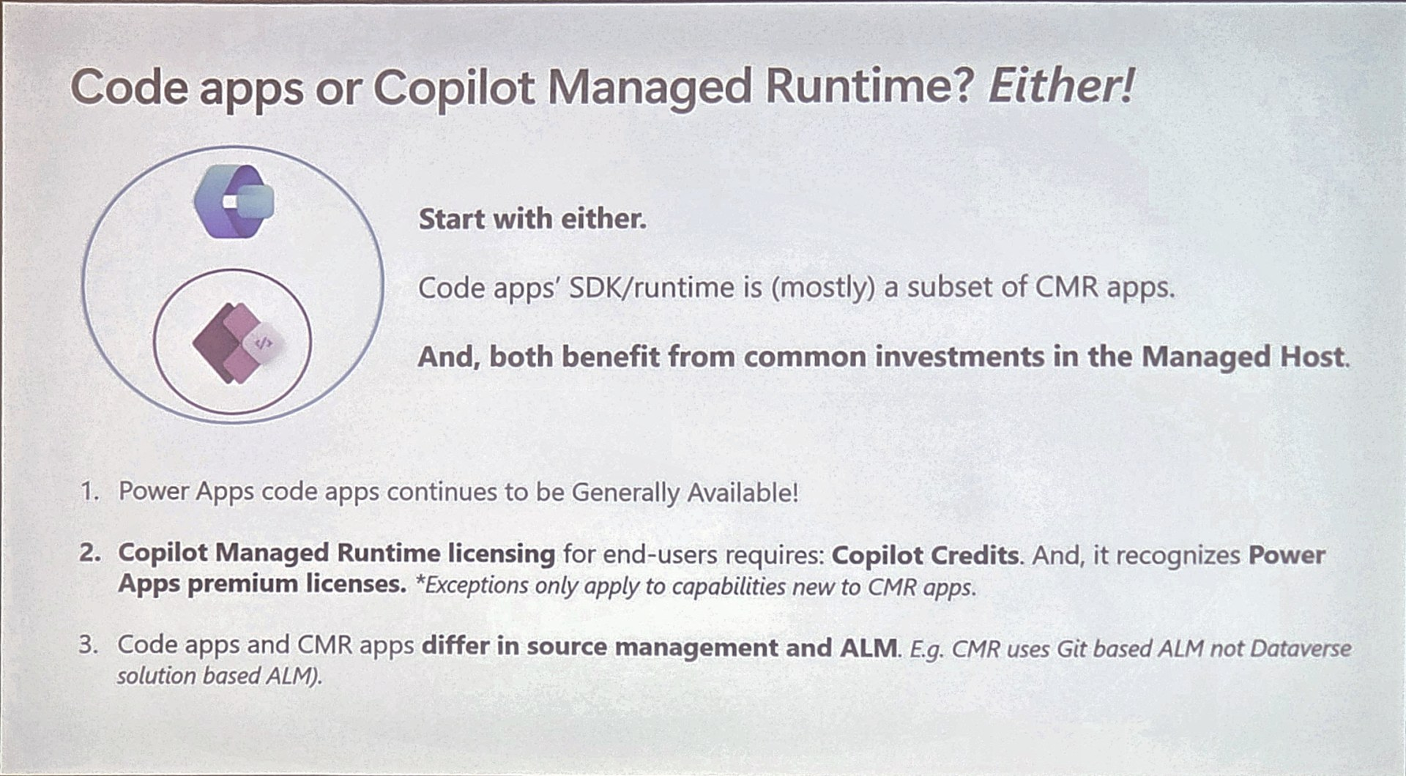
Code apps vs Copilot Managed Runtime

Session 7: Anything You Can Code, I Can Code Better: Managed Run Apps vs Power Pages
Speakers: Ulrikke Akerbæk, Scott Durow
Why it matters
A head-to-head build of the same app showed the clearest decision rule of the conference: external users point to Power Pages; internal, AI-built apps with Git-based ALM point to Managed Run Apps.

- Build and navigate: Power Pages SPA gives each view a unique URL; Managed Run Apps support deep links.
- Deployment: SPA is solution-aware and uses normal pipelines; Managed Run Apps use Git repos and pro-dev ALM, with the URL selecting version, local, or production.
- Data: SPA uses the Dataverse Web API and Power Automate; Managed Run Apps can use any connector plus custom APIs, with Dataverse security.
- Server-side work: SPA has server-side logic; Managed Run App synchronous calls have a 2-minute limit, so long-running work must be asynchronous.
- Builder options for Managed Run Apps: Copilot Studio Apps, Cowork (/app skill), GitHub Copilot, Claude Code, VS Code. App inventory is visible only in the admin portal.

Open Questions Answered
Questions raised in session notes, with findings from follow-up research. Items marked “unconfirmed” should be verified with Microsoft.
Question | Finding | Status
How are AI credits configured? | Power Platform admin center → Licensing → Copilot Studio → Manage Copilot Credits. Allocate prepaid credits per environment, set overage behavior, per-agent monthly limits, and usage alerts. Seeded AI Builder credits ended Nov 1, 2026. | Confirmed
What is “Governance” in the keynote? | Admin-center controls: agent settings in Power Platform admin center, publishing controls in Microsoft 365 admin center, audit in Purview. Inventory (Manage → Inventory) lists agents, apps, and flows. | Confirmed
What is the “agent map”? | Appears to be a Microsoft 365 admin center view of agents, including unmanaged ones. Licensing/role requirements reported by third parties only. | Unconfirmed
What MCP touches Copilot workflows? | Copilot Studio workflows can call MCP-compliant tools and knowledge servers as steps (GA July 15, 2026), under existing workflow governance. | Partially confirmed
Does the URL drive prod vs test in CMR? | Each app has a preview URL and a live URL; deploy promotes a build to live. Stage-specific targets (test/prod) are an opt-in CLI preview feature; new targets get their own URL. | Partially confirmed
What CMR roles exist? | Deck lists Project Owner, Contributor/Agent, and Approver. Creator, Developer, and Read-only were noted from the demo but not found in documentation. | Unconfirmed

Key Dates & Resources

Upcoming dates
Date | Item
Nov 1, 2026 (passed) | Seeded AI Builder credits ended
Nov 4, 2026 | Copilot Managed Runtime office hours, 10:00–10:30 AM PT
Nov 11, 2026 | Power Apps code apps office hours, 10:00–10:30 AM PT
Mid-November 2026 | Hourly Monitor alerts (public preview)
End of November 2026 | CMR projects & stages, alert routing trigger, Monitor data export, Power Pages health metrics (public previews)
Dec 2 / Dec 9, 2026 | CMR / code apps office hours
End of 2026 | Multi-environment CMR ALM preview; Autopilot broad rollout
Early 2027 | Code apps: Copilot side pane, Cowork hand-off, deep links

Resources
- Copilot Managed Runtime docs: aka.ms/ManagedApps
- Power Apps code apps docs: aka.ms/paCodeApps
- Git source code integration: aka.ms/SourceCodeIntegration
- Monitoring hub: aka.ms/MonitoringHub
- Copilot Studio Gallery: microsoft.github.io/copilot-studio-gallery
- Strategic intelligence demo solution: github.com/alicja-gilderdale/strategic-intelligence-operations-agent
- TALXIS lab: talxis.com/lab
- Agent Academy (free training): aka.ms/agent-academy
- The Copilot Compass: thecopilotcompass.com
- Copilot Credits capacity management: learn.microsoft.com/power-platform/admin/manage-copilot-studio-messages-capacity

Note on images: Slide photos were taken during sessions and have been straightened and enhanced. Some include live-caption text and “Microsoft Confidential” footers. Full slide sets are retained separately.

